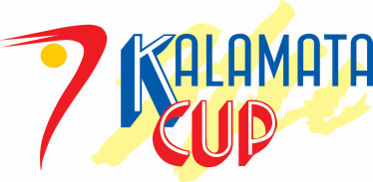
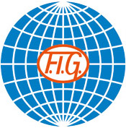
24th RG International Tournament
“Kalamata’s Cup 2016” April 22-24, 2016

April 12-14, 2013

Form to be sent to:
Organizing Committee
- Filogymnastikos Omilos Kalamatas
East Centre 14,Kalamata 24100
- Tel: 0030 6980162999
- e-mail : f.o.kalamatas@hotmail.com st4.k@hotmail.com
- Website: www.fok.gr
Deadline: FEBRUARY 24st, 2016
ACCOMMODATION Form

Federation |  | Contact Person:
 |  | Phone:
 |  | E-mail:

Package / Hotel name | Room type  (i.e. single/double/triple) | Arr. day | Dept. day | LAST NAME,  First Name | Function | Price per  person per night | # of nights | Total
 |  |  |  |  |  | GRAND TOTAL

Special requirements

Place and date | Seal of the NF | NF authorised signature
 |  | Signature of the President or Secretary General of the participating FIG affiliated NF

