24th RG International Tournament
“Kalamata’s Cup 2016”

April 22-24, 2016

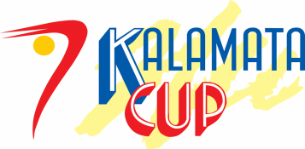

Form to be sent to:
Organizing Committee
- Filogymnastikos Omilos Kalamatas
East Centre 14,Kalamata 24100
- Tel: 0030 6980162999
- e-mail : f.o.kalamatas@hotmail.com st4.k@hotmail.com
- Website: www.fok.gr

Deadline: FEBRUARY 24th, 2016

Definitive registration

Federation |  | Contact Person:
 |  | Phone:
 |  | E-mail:

 | Senior Individual |  | Junior Individual |  | Senior  Group |  | Junior  Group
 | max. | number | max. | number | max. | number | max. | number
Head of Delegation (HD) | 1 |  | 1 |  | 1 |  | 1
Team Manager (TM) | 1 |  | 1 |  | 1 |  | 1
Coach | 2 |  | 2 |  | 2 |  | 2
Gymnasts | 4 |  | 4 |  | 6 |  | 6
Doctor | 1 |  | 1 |  | 1 |  | 1
Physiotherapist | 1 |  | 1 |  | 1 |  | 1
Judges | 1 |  | 1 |  | 1 |  | 1

Place and date | Seal of the NF | NF authorised signature
 |  | Signature of the President or Secretary General of the participating FIG affiliated NF

